Bold, italic, bold italic, underline, double underline, wavy underline, thick underline, dashed underline, underline color, strikethrough, double strikethrough, ^{superscript}, _{subscript}, font and size, color, highlight, border, shading, all caps, small caps, shadow, outline, emboss, imprint, spacing, scaling, position, style.
Center alignment
Right alignment
First line, left and right indent
very loooooooooooooooooooooooooooooooooooooooooooooooooooooooooooong text.
Double space before and after paragraph.
1.5 line spacing
second line.
Paragraph border
Second paragraph with the same style (inherits the border).
Paragraph shading.
Second paragraph with the same style (inherits shading).
Horizontal line:
Horizontal thick line:

- Bulleted list
- 2
- 3
  - Default bullet style for 2nd level
    - Default bullet style for 3rd level
- Numbered list; colored number
- 2
- 3

Table:
1 | 2 |  | 3 | 4
Bulleted list:
- 1
- 2
- List item
with multiple line

Nested table:
1 | 2
3 | 4
5 | 6

Conditional formatting:
1 | 2 | 3
4 | 5 | 6
7 | 8 | 9
Manual formatting | 11 | 12


Inline image: 
Wrap layout (square)

Floating image (in front of text):

OLE object (Paint drawing):
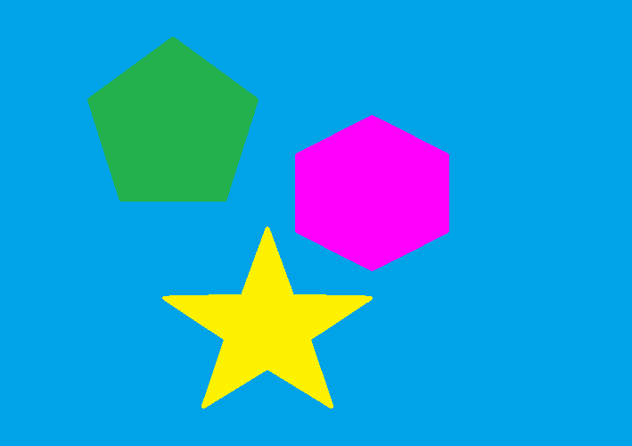
Signature line:
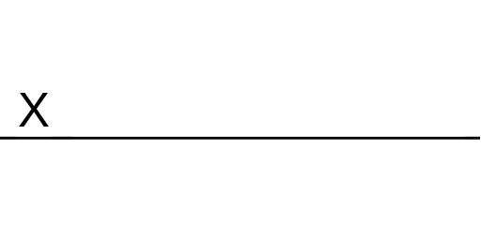
Ink:

Fields:
Number of words: 0
Author: MANFREDI

Form fields:
2

Complex multi-level list:
- First level
  - Second level
    - Third level
      - Fourth level
        - Custom bullets
        - Custom bullets
        - Custom bullets
          - Roman letters, enclosed in parentheses
          - 2
          - 3
          - 4
          - 5
      - Continue numbering
          - Skip fifth level; restart numbering
            - Picture bullet
- First level
- Override format
- Override number
Ordinal numbers:
- 1
- 2
- 3
Ordinal text:
- 1
- 2
- 3
Cardinal text:
- 1
- 2
- 3
Chicago manual style:
- 1
- 2
- 3
- 4
Circle enclosed numbers:
- 1
- 2
- 3

Heading 1

Heading 2
Bookmark here.
Paragraph with drop cap
second line
third line.
Symbols and emojis: 😊 😐 😊 ←→ ⬄
Hyperlink (absolute): DuckDuckGo
Hyperlink (relative): RTF (wordpad).rtf
Hyperlink to bookmark: Bookmark 1
Hyperlink to heading: Heading 1
Hyperlink to top

Footnote:
Endnote:
Comment:

Table of contents
Heading 1 6
Heading 2 6

Figure 1

Figure 1 7

Cross-reference: 5

Index item here

Index item here; 7

Quote item here
Casi
Quote item here 7

This section is landscape and has page borders, text in columns, hyphenation, line numbering and no header.

In this case, line numbering restarts on each page.

This section has A5 page size, smaller margins and an artistic border on the first page only.

The second page of this section has no borders.
Endnotes are displayed here (end of document) for all sections:

Footnote content
Endnote content

